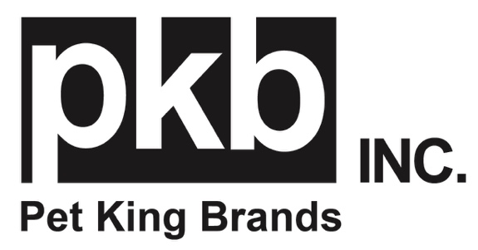
FOR IMMEDIATE RELEASE
MEDIA CONTACT: Kerry Sutherland, Parker Samuelson
Kerry@ksutherlandpr.com
Parker@ksutherlandpr.com

Bury the Brush with Pet King Brands’ Oratene®
Harness the power of enzymes for fresh breath and healthy gums.

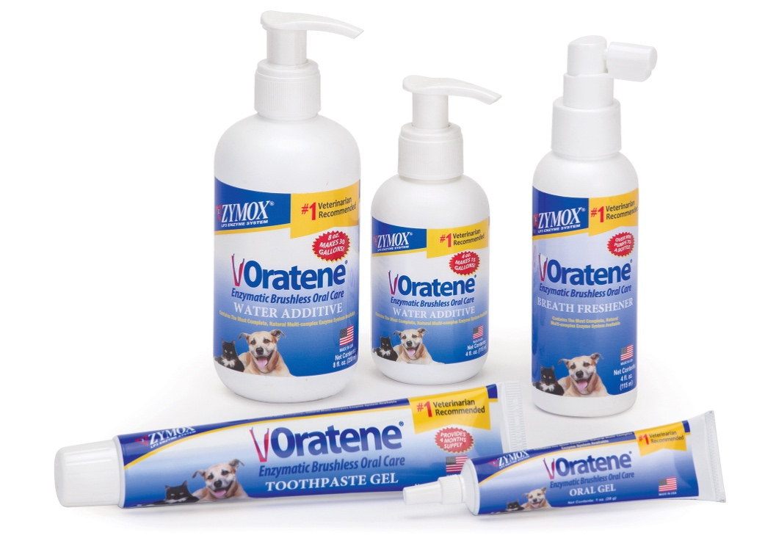

Learn more at Global Pet Expo 2024 at Pet King Brands Booth #4609

(Austin, TX)- Pet King Brands, the pioneering leader of the veterinarian-recommended LP3 Enzyme System, is proud to share their line of Oratene® Enzymatic Brushless Oral Care products.

Oratene Brushless Oral Care offers superior oral protection against bad breath, plaque and periodontal disease by delivering two complete, patented enzyme systems not found in any other enzymatic oral care line. These products effectively inhibit the bacteria that cause bad breath, boost the natural oral flora, help protect against gum disease and dissolve plaque biofilm.

“Our Oratene line offers a simple and effective solution to pet oral care,” said Debra Decker, Pet King Brands Director of Marketing. “Each product features a natural, multi-complex enzyme system that doesn’t require brushing to maintain oral health.”

Oratene Water Additive features two complete enzyme systems based on 40 years of advanced enzyme technology in a flavorless concentrate to be added to fresh drinking water daily and is recommended for all pets in need of gentle, non-drying everyday oral care.

The Breath Freshener Spray contains the same enzyme system and delivers a gentle mist to freshen any pet’s breath, especially beneficial to pets prescribed medication which may cause Xerostomia.

Oratene Enzymatic Brushless Toothpaste Gel provides maximum enzyme contact to keep pet’s teeth and gums clean and fresh. This clear gel is pleasant tasting and may be applied with a toothbrush or a finger.

The Brushless Oral Gel provides maximum enzyme contact for relief from serious conditions such as periodontal disease, gingivitis, stomatitis and inflamed gums and ulcerations. Oratene Oral Gel is the most potent enzyme formulation in the Oratene product line, featuring a mildly sweet, non-bitter flavor that won’t stain teeth or cause excess salivation.

For more information, visit www.zymox.com. If you are a member of the media and would like to request more information, hi-res images or an interview with Pet King Brands founders, please contact Kerry Sutherland at K. Sutherland PR, (775) 360-6101 or kerry@ksutherlandpr.com.

If you are attending Global Pet Expo 2024 in Orlando, Florida, please visit us at Pet King Brands Booth #4609

-###-
About Pet King Brands
Pet King Brands, the maker of ZYMOX® Ear and Skin products, Oratene® Brushless Oral Care, Equine Defense®, and ZYLAFEN®, is a leader in veterinarian-approved pet products made in the USA. Focused on the health and wellness of small and large animals of all ages, the products utilize the Power of the LP3 Enzyme System and have been Resolving Ear, Skin, and Oral Conditions for Over 25 Years. Led by President and Founder Pamela Bosco, who first introduced ZYMOX in 1998 with the help of her bioscientist brother, Michael Pellico, Pet King Brands has revolutionized the way people care for animals' ears, skin, and mouth, offering solutions that are gentle to the animal, easy to administer and free of harsh chemicals and antibiotics.

