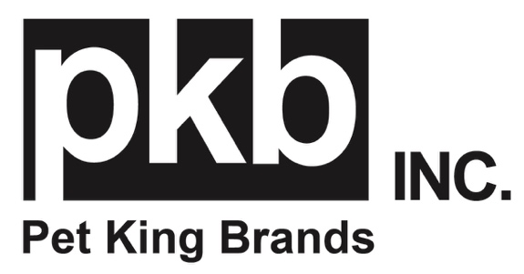
FOR IMMEDIATE RELEASE
MEDIA CONTACT: Kerry Sutherland, Parker Samuelson
Kerry@ksutherlandpr.com
Parker@ksutherlandpr.com

Pet King Brands Announces New ZYMOX Advanced Enzymatic Ear Wipes for Dogs and Cats
Veterinarian-approved to clean, soothe and freshen.
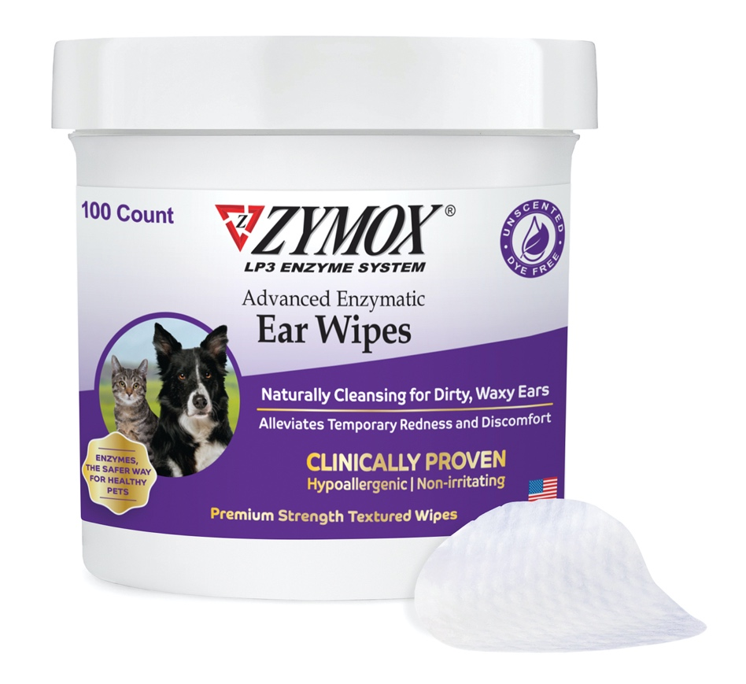
Learn more at Global Pet Expo 2024 at Pet King Brands Booth #4609

(Austin, TX)- Pet King Brands, the pioneering leader of veterinarian-recommended enzymatic pet health brands ZYMOX® Dermatology and Oratene® Brushless Oral Care, is proud to announce the addition of Advanced Enzymatic Ear Wipes to their flagship line of Ear Care products for dogs and cats, including Enzymatic Ear Solution with .5% Hydrocortisone, Enzymatic Ear Solution Hydrocortisone Free and Enzymatic Ear Cleanser.

This new product features the renowned ZYMOX LP3 Enzyme System, an effective yet gentle antibiotic alternative that is non-reactive and non-toxic. Unlike antibiotics, antimicrobial enzymes selectively target single-celled organisms, preventing disturbance to the normal flora. The LP3 Enzyme System is so effective that it need only be applied once daily and does not require pre-cleaning.

“Our mission and heart lie in animal advocacy, so we are very excited to announce another non-toxic preventative care product,” said Debra Decker, Pet King Brands Director of Marketing. “These Ear Wipes further our strides in the effort of increasing quality of life for our furry best friends.”

Each jar contains 100 premium strength textured wipes that naturally cleanse dirty, waxy ears to calm and soothe irritation, alleviate temporary redness and reduce ear odor.
Textured wipes meet soothing Aloe Vera to increase pet parent grip ability and alleviate discomfort by calming and moisturizing the skin.

Easily store the fragrance free, dye free and alcohol-free wipes in the jar for convenience with daily use. The Advanced Enzymatic Ear Wipes for Dogs and Cats retail for $21.99.

For more information, visit www.zymox.com. If you are a member of the media and would like to request more information, hi-res images or an interview with Pet King Brands founders, please contact Kerry Sutherland at K. Sutherland PR, (775) 360-6101 or kerry@ksutherlandpr.com.

If you are attending Global Pet Expo 2024 in Orlando, Florida, please visit us at Pet King Brands Booth #4609

-###-

About Pet King Brands
Pet King Brands, the maker of ZYMOX® Ear and Skin products, Oratene® Brushless Oral Care, Equine Defense®, and ZYLAFEN®, is a leader in veterinarian-approved pet products made in the USA. Focused on the health and wellness of small and large animals of all ages, the products utilize the Power of the LP3 Enzyme System and have been Resolving Ear, Skin, and Oral Conditions for Over 25 Years. Led by President and Founder Pamela Bosco, who first introduced ZYMOX in 1998 with the help of her bioscientist brother, Michael Pellico, Pet King Brands has revolutionized the way people care for animals' ears, skin, and mouth, offering solutions that are gentle to the animal, easy to administer and free of harsh chemicals and antibiotics.

