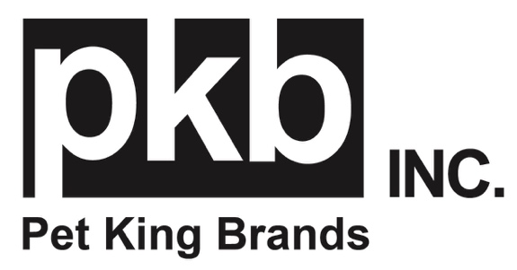
FOR IMMEDIATE RELEASE
MEDIA CONTACT: Kerry Sutherland, Parker Samuelson
Kerry@ksutherlandpr.com
Parker@ksutherlandpr.com

Soothe and Support: Pet King Brands Highlights ZYMOX Dermatology Line
Provide relief with the soothing power of enzymes.
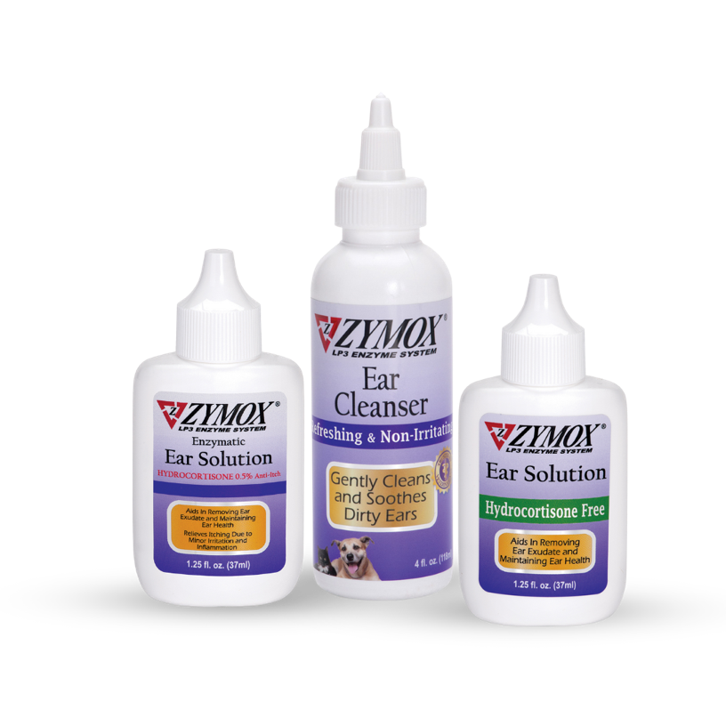
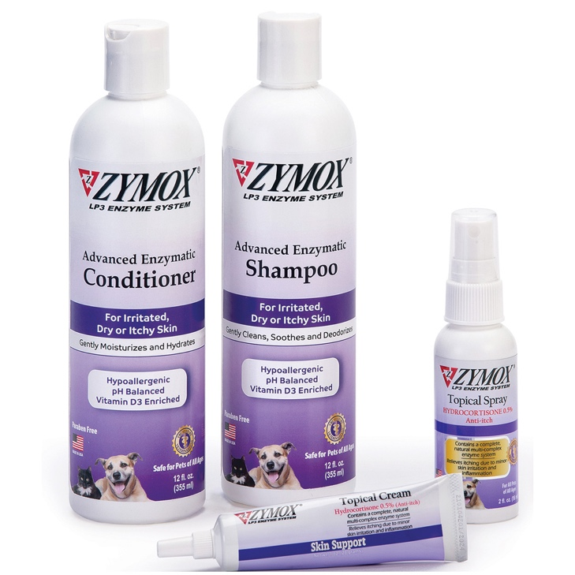

Learn more at Global Pet Expo 2024 at Pet King Brands Booth #4609

(Austin, TX)- Pet King Brands, the pioneering leader of the veterinarian-recommended LP3 Enzyme System, is proud to share their line of ZYMOX® Dermatology Skin and Ear products.

These non-toxic, topical products feature a natural, multi-complex enzyme formulation to gently calm and promote healthy skin without harsh ingredients. Recommended by veterinarians and groomers to support the optimal health of skin, these products faithfully act as your pet’s first line of defense.

“Our non-toxic solutions with easy-to-follow protocols are the perfect solution to itchy, inflamed skin,” said Debra Decker, Pet King Brands Director of Marketing. “Our pets can experience allergies, too, and these formulas provide relief while doing no harm.”

The Advanced Enzymatic formula comes in a Shampoo and Conditioner, used for gentle cleansing and healthy skin support on irritated or inflamed skin. This non-irritating system is tear-free and safe for all animals.

The ZYMOX formula comes in a Shampoo, Conditioner and Leave-On Conditioner containing Vitamin D3 for skin health and uses mild, non-drying ingredients that are soothing to the skin, pH-balanced, tear-free and paraben free.

The ZYMOX Topical Spray with .5% Hydrocortisone promotes healthy skin and provides relief from itching caused by inflammation, dermatitis and other minor skin irritations. It features the patented LP3 Enzyme System which blends a concentrated combination of protein and enzymes plus skin soothing aloe vera and 0.5% hydrocortisone for itch relief. The Spray is ideal for areas away from the face.

The ZYMOX Topical Cream with 0.5% Hydrocortisone contains the same formula as the Topical Spray, but features a catheter tip for direct application, ideal for areas around the face, paws and body folds.

The new ZYMOX Advanced Enzymatic Ear Wipes are perfect for daily use and contain Aloe Vera which helps to alleviate temporary redness and discomfort by calming and moisturizing the skin, and menthyl lactate that helps to soothe irritated skin.

The ZYMOX Enzymatic Ear Solution with .5% Hydrocortisone promotes healthy ears by utilizing enzymes in removing ear exudate and relieves itching due to minor inflammation, dermatitis and other minor skin irritations.

The ZYMOX Enzymatic Ear Solution Hydrocortisone Free is perfect for use on any age dog, cat or exotic animal, as well as those that are pregnant or lactating.
The ZYMOX Enzymatic Ear Cleanser provides an effective, non-toxic and gentle way to manage dirty ears, perfect for long term cleaning.
Pet King Brands also carries a line of Veterinary Dermatology products, both with and without hydrocortisone.

For more information, visit www.zymox.com. If you are a member of the media and would like to request more information, hi-res images or an interview with Pet King Brands founders, please contact Kerry Sutherland at K. Sutherland PR, (775) 360-6101 or kerry@ksutherlandpr.com.

If you are attending Global Pet Expo 2024 in Orlando, Florida, please visit us at Pet King Brands Booth #4609

-###-

About Pet King Brands
Pet King Brands, the maker of ZYMOX® Ear and Skin products, Oratene® Brushless Oral Care, Equine Defense®, and ZYLAFEN®, is a leader in veterinarian-approved pet products made in the USA. Focused on the health and wellness of small and large animals of all ages, the products utilize the Power of the LP3 Enzyme System and have been Resolving Ear, Skin, and Oral Conditions for Over 25 Years. Led by President and Founder Pamela Bosco, who first introduced ZYMOX in 1998 with the help of her bioscientist brother, Michael Pellico, Pet King Brands has revolutionized the way people care for animals' ears, skin, and mouth, offering solutions that are gentle to the animal, easy to administer and free of harsh chemicals and antibiotics.

